Work Instruction for
USAGE/ MAINTENANCE OF LEAD ACID BATTERY, AND BATTERY DISPOSAL

Objective: Battery maintenance and disposal of battery.

Scope: Battery bank and DG battery

Ref: Maintenance manual and Battery disposal rule.

- Aspect: Waste generation, Fumes generation, Fire, Electrolyte leakage
- Impact: Resource depletion, Air pollution and land contamination.
- Hazards: Inhalation of acidic fumes, Fire and explosion due to short circuit ,battery explosion,Acid Splashing.
- Behavioural Hazards: Non adherence to SOP, non usage of battery maintenance safety PPE's

BATTERY MAINTENANCE

- Ensure use of Below safety PPE’S before carrying out battery maint.
The PPE are available at Electrical workshop.


Acid proof gloves Goggles Insulated Spanners Nose mask

FACE MASK
Responsibility: Electrician.

- Even while taking round for routine inspection in Battery room /Battery charging area, person must wear Safety googles.

- Unauthorised entry inside the Battery room is prohibited. To avoid unauthorise entry battery room has been kept locked.

- It is Compulsory to use Googles , nose mask/face mask , acid proof gloves and acid proof apron while carrying battery maintenance. In case acid comes in contact with eyes, flush with clean water and seek medical attention immediately
Responsibility: Electrician.

- Ensure DG's are not running and the external battery charger is put off.

Responsibility: Electrical Engineer and Electrician.

- While connecting or disconnecting the battery lead, ensure to turn battery charger off. While connectiong the battery leads, connect the positive lead first , then the negative lead to avoid sparks.

Responsibility: Electrical Engineer and Electrician.

- Use proper insulated spanners for disconnection of batteries which are made available at electrical workshop.

Responsibility: Electrician.

- Never short the terminals of the battery.

- Check battery cell specific gravity and note down in the standard format.

Responsibility: Electrician.

- Carry out the battery load test and see back up capacity at 10 amps load for 08 hrs and same has to be monitored for every two hrs during load test. For battery load test, loads are already made available at the respective battery bank location.

“While carrying out battery load test, ensure that battery bank is not isolated from the load circuit. This is in order to supply pure 110 volt DC to the utilities.”
Responsibility: Electrical Engineer and Electrician.

- Check the battery electrolyte level and top up if necessary by using distilled water, level should be 10 to 15 mm above the battery plates.

Responsibility: Electrician.

12.Do not take specific gravity readings immediately after adding distilled water .

Responsibility: Electrician.

13.Clean the batteries by using plain cotton cloth.

Responsibility: Electrician.

14. Care should be taken to prevent the spillage of battery electrolyte.

Responsibility: Electrician

15.Clean and tighten all the connections. Use insulated tools only to avoid short circuit between positive and negative terminal of the battery.

Responsibility: Electrical Engineer and Electrician.

16.Apply petroleum jelly to the terminals to avoid oxidation.

Responsibility: Electrician.

17.While turning the Charger ON , slowly increase the the charging rate .If fumming or discharge of battery electrolyte from cell occurs, turn the Charger OFF.

Responsibility: Electrical Engineer and Electrician.

18.If there is no fuming or dicharge of battery electrolyte from cell occurs charge batteries in boost mode till specific gravity reaches to its rated value.

Responsibility: Electrical Engineer and Electrician.

19.Battery charging is to be monitored every two hours, and once the batteries are charged, keep trickle charging @ +0.5 amps charging rate .

Responsibility: Electrical Engineer and Electrician.

20. Use hand trolley for shifting battery . For placing battery on the battery stand , two persons need
to lift the battery with the help of insulated battery lifting rod available at battery station location.

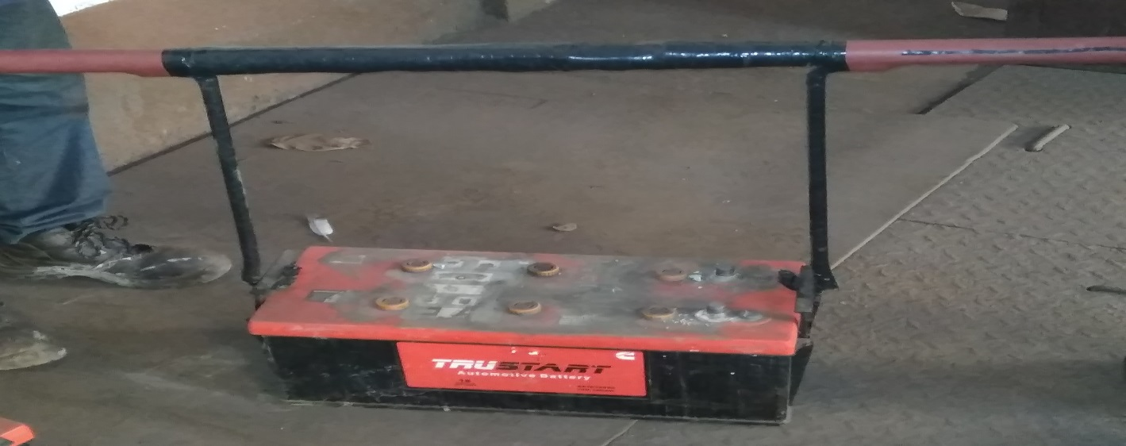

Responsibilty: Electrican Engineer and Electrician.

21.While carrying out maintenance on battery ensure that the battery room exhaust fan is running and the windows are kept open so there is proper ventilation in the room.

Responsibilty: Electrican Engineer and Electrician.

BATTERY DISPOSAL
- Carefully disconnect the battery using insulated spanners.
Responsibility: Electrician.

- Empty the electrolyte in a container, And send the same to laboratory for neutralising.
Responsibility: Electrical Engineer and Electrician

- After neutralising of battery tag batteries and return to store under buy back scheme.

Responsibility: Electrical Engineer and Electrician

- Tag scrap batteries as „ Kept for disposal to stores.“

Responsibility: Area Electrical Engineer
- While indenting new batteries, Identification number of old scrap batteries which will be returned to the stores will be mentioned in the PRQ and PO
Responsibility: Indentor.
- While withdrawing new battery from stores , old kept ready for disposal battery to be returned to stores before taking custody of new battery.

Amendement Record
Date | Manual Section Ref. & Para | Brief details of Revision | New Rev.

Prepared By:  Senior Elect. Engineer | Reviewed & Issued By:  Management Representative | Approved By:  Head – Electrical & Instrumentation PID I
Signature | Signature: | Signature:
Review Date: 04.03.2023 | Review Date: 04.03.2023 | Review Date: 04.03.2023

